|  |
| --- |
| **STUDENT NAME** |
| Alley Chaggar |

**LAB #10**

ACTIVITY 1 2

# ACTIVITY 1

## SETTING UP GIMP FOR PIXEL ART - PALETTE

Pixel Art is a form of art, that design is based on pixels. Each pixel can be assigned with a single color and if we combine them, we can render complete images. Pixel art is extensively used for designing game characters and other assets. This tutorial demonstrates how to setup GIMP for Pixel Art and how to design a simple asset, using a Palette.

Follow the steps below:

1. Open the CountDracula image on GIMP (or the CountDracula.xcf file).
2. Using the previously acquired knowledge create:
   1. 3 Walk animation stances.
   2. 2 Jump animation stances.
   3. 3 Attack animation stances.
   4. 3 Idle animation stances.
3. Export them as separate images and save them to separate Walk, Jump, Attack and Idle folders under the CountDracula asset folder.
4. Double click on the Texture Packet shortcut icon.
5. Drag and drop all the assets in the sprites’ list.
6. Click on the Publish Sprite Sheet button and save the new sprite sheet, as CountDraculaSpriteSheet.

|  |
| --- |
| **TASK 1.1:**  Locate the CountDraculaSpriteSheet and add it to the submission folder. |
| upload iconIn the LMS, add the file to the assignment Lab #10 submission folder. You can submit multiple files at a time. |

1. Double – click on the Unity Hub shortcut on your desktop.
2. Open the Pixel Art Example project from Quiz#5.1.
3. Delete the existing CountDracula asset.
4. Drag and drop the CountDracula spritesheet in the CountDracula folder under the Characters folder in the project tab.
5. Click on the CountDracula image and at the Inspector set the Sprite Mode to Multiple.
6. Click on the Sprite Editor button.
7. In the Sprite Editor click Slice 🡪 Automatic 🡪 Slice.
8. Name the sprites according to their body stance.
9. Click Apply.
10. Close the Sprite Editor.
11. Using the Sprites after the slicing open the Animation windows and with the previously acquired knowledge create the below animations:
    1. Walk (normal walk sprites).
    2. Run (use the walk sprite increasing the frame rate).
    3. Jump (jump sprites).
    4. Attack (attack sprites).
    5. Idle (idle sprites).
12. Save them to a separate animation folder inside the CountDracula character folder.
13. Open the Animator window (Window 🡪 Animation 🡪 Animator).
14. Connect the animations with transitions as shown below:  
      
    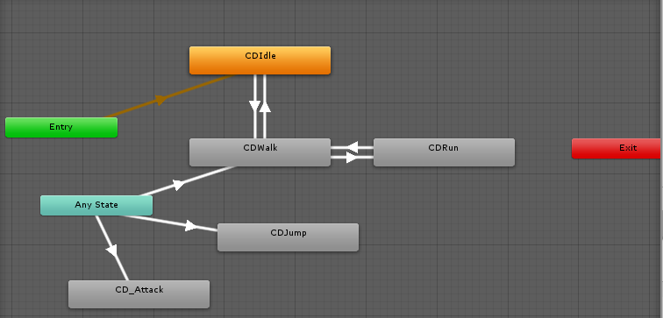
15. Create the parameters Speed, isAttacking and isJumping.
16. Using the walk script from the Lab #10 Support File, create a new script named CountDraculaController and animate the CountDracula character based on the Animator scheme above.

|  |
| --- |
| **TASK 1.2:**  Compress and upload the Unity project and add it to the submission folder. |
| upload iconIn the LMS, add the file to the assignment Lab #10 submission folder. You can submit multiple files at a time. |

FINAL STEP: Save this document as a PDF. Upload the PDF to the Lab #10 submission folder.